**Big Mountain Resort - Pricing Recommendations**

**Problem Statement**

Big Mountain is a ski resort located in the state of Montana. It charges a premium compared to other resorts, but may be leaving money on the table. To maximize revenue, they would like to understand what ticket price their facilities justify and how they might modify facilities and prices in the future.

**Data Wrangling**

A CSV dataset with 330 resorts and 27 features was obtained from our database manager. I plotted histograms of all numerical features to identify any erroneous data. After some data cleanup, 277 resorts and 25 features remained. The target variable was chosen to be the Adult Weekend ticket price because it is highly correlated with Adult Weekday ticket price but had fewer missing values.

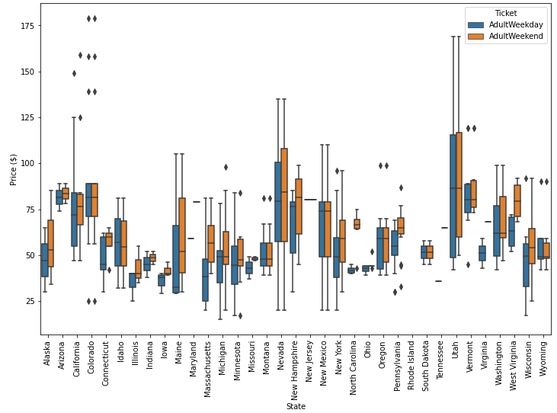

**Exploratory Data Analysis**

I examined the data using charts (scatter and histogram), particularly through the lens of state level groupings. With so many features, I used principal components analysis (PCA) to create

derived features which could explain the variance in a lower dimension. In this case, over 75% of the variance was explained by the first 2 PCA components. There was no clear grouping based on states so normalizing values by state size or state population was deemed the appropriate method of feature engineering. Using my business intuition, I created several other features which were ratios of existing features such as “total chairs per run ratio” and “total chairs to skiable area ratio.” Using a correlation heatmap, I was able to understand the potential interaction between certain features.

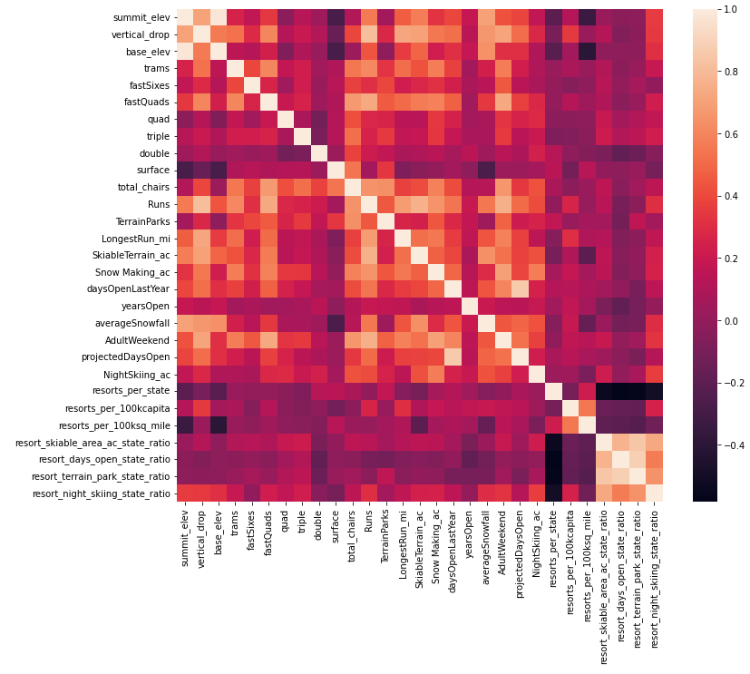

**Model Preprocessing**

For a quick baseline, I predicted Adult Weekend prices as the mean of our dataset. This gave R-squared=0, Mean Absolute Error=$19, and Root Mean Squared Error=$24. I tested both linear regression and random forest models. I used cross-validation to repeatedly split the dataset into training and test subsets to avoid overfitting. In the end, the random forest model was chosen since it had better Mean Absolute Error of $9.54 versus $11.79 with less variability. Below is a graph showing feature importance for this model:

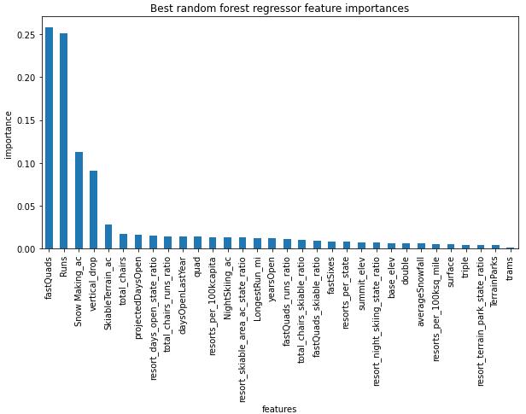

**Model Pricing**

Big Mountain currently charges $81 for an Adult Weekend ticket. Here is how Big Mountain’s ticket price currently compares to its competitors:

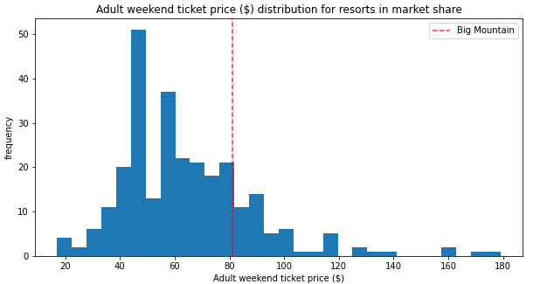

Looking at percentiles for key features, the resort ranks highly in many:

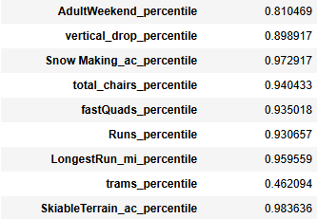

Running the random forest model to predict Big Mountain’s price gave a value of $95.87 with a mean absolute error of $10.39. This suggests a possible range of $85.48 to $106.26. There is certainly room to increase the Adult Weekend ticket price.

Big Mountain gets approximately 350,000 visitors per year who buy 5 tickets. This equates to $141,750,000 in annual revenue at $81. If they were to be conservative and increase price by only $4.48, this would add an additional 5.5% to revenue or $7,840,000.

**Scenario Modeling**

Several scenarios have been shortlisted by executives. My report does not consider the costs for maintenance or operating, so I will be looking from a purely revenue perspective. Scenario 2 called for adding a run, increasing vertical drop by 150 feet, and installing an additional chair lift. This proved to be the most effective of the four and is my recommendation. It would support a ticket price increase of $1.99 which would amount to $3,474,638 for the season. This would easily recoup the $1,540,000 cost of the chair lift.

**Further Analysis**

The resort data used for this analysis only considers the impact on ticket price. For a more complete picture, additional data would be needed:

* Maintenance and operational costs of lifts, snowmaking, etc.
* Profile of visitors including income, home state, etc for the purpose of determining how price sensitive they are
* Usage of runs and trams to determine the best ones to remove
* Historical data on ticket pricing and resort features to understand consumer trends